RED LAKE NATION COLLEGE
Assessment Plan Instruction Manual/Workbook

Revised June 2019

Table of Contents

Contents
Components of the Assessment Plan 3
Mission 3
Goals 4
Measures 7
Targets 11
Sampling 13
Interpret Results 14
Report 15
Act on Results 16
RLNC Form for Assessment Planning 19

Components of the Assessment Plan
The graphic below shows the six components of an assessment plan. It is important to create the components in the correct order.

Mission
The institutional mission is the foundation upon which everything we do is based. Departmental mission statements and program mission statements should flow from and directly support the overall institutional mission.
RLNC Institutional Mission Statement:
To provide excellent higher education that is grounded in the Ojibwe language and culture of the Red Lake Nation.

RLNC Liberal Education Program Mission Statement:
To provide students an exposure to the Ojibwe language and allow them the opportunity to understand Anishinaabe values and how these values can provide a foundation for lifelong learning and community involvement.

Now, enter your mission statement:
RLNC Institutional Mission Statement:
To provide excellent higher education that is grounded in the Ojibwe language and culture of the Red Lake Nation.

Program Mission Statement:

Goals
We use program goals to help frame our thoughts about the expectations we have for our students. Based on the mission of the program, what hopes and aspirations do program faculty have for program graduates three to five years after graduation?
RLNC Liberal Education A.A. Degree Program Goals
- Program graduates will further their academic study by completing a baccalaureate after transfer to another college or university.
- Program graduates will find employment on the Red Lake Indian Reservation.

Now, enter your program goals:
1.

2.

3.

Outcomes
- Write outcome statements that directly support at least one program goal.
- Write outcome statements that relate directly to the academic discipline and reflect the knowledge and skills students should acquire.
- Write outcome statements that are observable and measurable
- Write outcome statements that focus on knowledge and skills graduates should possess rather than curriculum design, department resources, faculty characteristics, or instructional methods.
- For programs that have specialized accreditation or certification, write outcome statements that take those assessment expectations into consideration.
- Write outcome statements that do not combine multiple outcomes in a single statement.
- Write outcome statements that are short and concise.
- Write outcome statements in the form of “Graduates of the ________program will be able to _______;” or “Graduates of the ___________program will be prepared to ______.”
- You should have 3-5 program outcomes.

RLNC Liberal Education A.A. Degree Outcome Goals:
- Graduates of the Liberal Education A.A. Degree Program will be prepared to effectively communicate with coworkers and supervisors through verbal interactions.
- Graduates of the Liberal Education A.A. Degree Program will be able to use evidence to analyze logical connections in order to make decisions and effectively problem-solve.
- Graduates of the Liberal Education A.A. Degree Program will be prepared to effectively communicate with coworkers and supervisors through written interactions.
- Graduates of the Liberal Education A.A. Degree Program will be prepared to communicate via various mediums of technology (video, audio, Microsoft Word, Microsoft PowerPoint, email).

Using Outcome Goal #1: Graduates of the Liberal Education A.A. Degree Program will be prepared to effectively communicate with coworkers and supervisors through verbal interactions.
Guidelines | Are the guidelines met?
Support one or more long-term goals | This outcome is directly related to both of our long-term goals.
Directly related to discipline. | This outcome is directly related to the Liberal Education A.A. degree program.
Observable and measurable | There are many ways in which faculty can ask students to demonstrate their ability to communicate effectively through verbal interactions.
Focused on outcomes rather than inputs | Demonstration of verbal communication is outcome-focused.
Consider external standards, if any | No accreditation standards apply.
Avoid combining multiple outcomes | This is a single outcome.
Short and concise | This is short and concise.
Students will be able (or prepared) to _______ | This is in the correct form.
Now enter your program outcomes:
1.
2.
3.

Evaluate Outcome #1
Guidelines | Are the guidelines met?
Support one or more long-term goals
Directly related to discipline.
Observable and measurable
Focused on outcomes rather than inputs
Consider external standards, if any
Avoid combining multiple outcomes
Short and concise
Students will be able (or prepared) to _______

Evaluate Outcome #2
Guidelines | Are the guidelines met?
Support one or more long-term goals
Directly related to discipline.
Observable and measurable
Focused on outcomes rather than inputs
Consider external standards, if any
Avoid combining multiple outcomes
Short and concise
Students will be able (or prepared) to _______

Evaluate Outcome #3
Guidelines | Are the guidelines met?
Support one or more long-term goals
Directly related to discipline.
Observable and measurable
Focused on outcomes rather than inputs
Consider external standards, if any
Avoid combining multiple outcomes
Short and concise
Students will be able (or prepared) to _______

Measures
Identify three measures for each outcome. The first and second measures must be direct measures, and the third must be an indirect measure.
A direct measure is one in which students demonstrate their learning through a performance of some kind. Direct measures include exams, projects, and other activities where the students actually demonstrate their knowledge or skill. An indirect measure is one that provides information from which we can draw inferences about student learning. Indirect measures do not call on students to demonstrate their knowledge or skill, but rely on information reported by the students or by some third party about the level of student knowledge or ability. Surveys and employment data are the most common indirect measures.
Direct Measures | Indirect Measures
Capstone (project/paper/portfolio) | Student surveys and focus groups
Presentations/oral defenses | Exit surveys and interviews
Classroom exams or quizzes | Alumni surveys and interviews
Classroom/homework assignments | Job placement data
Course projects | Admission to further academic study
Papers | Course evaluations
Artistic creations or performances
Classroom discussions
Online discussion threads
Certification exams
There are several important guidelines to consider when identifying appropriate measures for your outcomes:
- Avoid creating additional tests or other assessment activities simply to satisfy your assessment data collection needs.
- Course grades are not appropriate measures of student learning. It is appropriate to use the grade on a specific exam, project, etc. that specifically measures student learning on the outcome. Course grades are based on overall satisfaction of course requirements rather than performance on a specific program-level outcome.
- Use at least one direct measure.
- Course completion is not an appropriate measure of student learning.
- Identify a specific measure (instead of saying tests, identify a specific test).
- Don’t write a long description of the measure.
- Don’t combine multiple measures as one.

Using Outcome Goal #1: Graduates of the Liberal Education A.A. Degree Program will be prepared to effectively communicate with coworkers and supervisors through verbal interactions.
RLNC Liberal Education A.A. Degree Program Measures for Outcome Goal #1:
- Final Speech Project in SPCH 201 (Speech and Communications)
- Argumentation Essay in ENGL 101 (English Composition I)
- Student satisfaction regarding verbal communication via exit survey

Using Program Measure #1: Final Speech Project in SPCH 201 (Speech and Communications)
Guidelines | Are the guidelines met for each measure?
No unnecessary test for assessment purposes | This is a regularly scheduled assignment.
No course grades | This is not a course grade
No course completions | This is not a course completion
At least one direct measure | This is a direct measure
Specific measure | This is a specific assignment
No long description | This is a short description

Now, enter your measures for Outcome #1:
1.

2.

3.

Now, enter your measures for Outcome #2:
1.

2.

3.

Now, enter your measures for Outcome #3:
1.

2.

3.

Evaluate Measures for Outcome #1
Guidelines | Are the guidelines met for each measure?
No unnecessary test for assessment purposes
No course grades
No course completions
At least one direct measure
Specific measure
No long description

Evaluate Measures for Outcome #2
Guidelines | Are the guidelines met for each measure?
No unnecessary test for assessment purposes
No course grades
No course completions
At least one direct measure
Specific measure
No long description

Evaluate Measures for Outcome #3
Guidelines | Are the guidelines met for each measure?
No unnecessary test for assessment purposes
No course grades
No course completions
At least one direct measure
Specific measure
No long description

Targets
For each measure, we will set a primary target that will identify the level of performance necessary to ascertain whether student performance on the measure indicates that the program outcome has been achieved. Not all students will perform perfectly on every measure, so program faculty must identify a threshold above which they will be satisfied that, on a whole, students who graduate from the program possess the knowledge or skill specified in the outcome.
Examples:
- 80% or more of students will earn a grade of B or higher on the final exam.
- 80% or more of alumni survey respondents will report that they are currently employed in a field that is related or closely related to their degree program.
- 75% or more of sampled papers reviewed will be evaluated at a level of “Satisfactory” or higher, using a faculty-developed rubric.
Guidelines:
- The target must be directly related to the measure. If the measure is an exam, the target will be a threshold of performance on the exam.
- Write targets in this format: “XX% of students will earn a grade of X or higher on the (name of exam/project).”
- Course grades and course completions are not appropriate for use in targets.

Using Program Measure #1: Final Speech Project in SPCH 201 (Speech and Communications)

RLNC Liberal Education A.A. Degree Program Target for Program Measure #1
70% of students who complete the course will earn a grade of C or higher on the Final Speech Project in SPCH 201 (Speech and Communications).

Guidelines | Are the guidelines met?
Directly related to the measure | This target relates directly to the measure
Written in the correct format | This target is written in the correct format
No course grades or completions | This is not a course grade or completion

Now, enter your targets (relate to each measure):
Target for Measure #1
1.
2.
3.
Target for Measure #2
1.
2.
3.
Target for Measure #3
1.
2.
3.

Evaluate Targets for Measure #1
Guidelines | Are the guidelines met?
Directly related to the measure
Written in the correct format
No course grades or completions

Evaluate Targets for Measure #2
Guidelines | Are the guidelines met?
Directly related to the measure
Written in the correct format
No course grades or completions

Evaluate Targets for Measure #3
Guidelines | Are the guidelines met?
Directly related to the measure
Written in the correct format
No course grades or completions

Sampling
As part of your assessment planning process, you will identify a sampling strategy for each measure. It is important to think about sampling during this early stage of your assessment cycle.
Guidelines for identifying and documenting your sampling strategy:
- The sampling strategy statement reflects a before the fact decision about how you will select a reasonably representative group of program majors AND minimally answers the following questions:
- How many students will be included in data collection?
- Who will those students be?
- What timeframe is associated with data collection? This is dictated by when the course is offered during the academic year.
- Other unique parameters (freshmen, sophomores).
- The only students who should be included in your sampling are program majors. Do not include students who are enrolled in a class used for data collection that associated with other programs.
Examples of sampling strategies include:
100% of ________ program majors enrolled in (course number) during ______ term.
80% of _________ program majors enrolled in all three sections of course number during both academic terms of AY 14-15.
Using Target #1: 70% of students who complete the course will earn a grade of C or higher on the Final Speech Project in SPCH 201 (Speech and Communications).
RLNC Liberal Education A.A. Degree Program Sampling Frame:
100% of student who complete SPCH 201 (Speech and Communications) will be included in the data collection.
Now, select your sampling frame for each target:

Now, enter your sampling frame for each Target:
Sampling frames for the 3 targets for measure #1:
1.
2.
3
Sampling frames for the 3 targets for measure #2:
1.
2.
3.
Sampling frames for the 3 targets for measure #3:
1.
2.
3.

Interpret Results
In the data interpretation phase of your assessment work, program faculty will use the assessment data collected during the academic year to determine whether program graduates have the knowledge or skill descried in each learning outcome. Data interpretation should occur as soon as possible after data collection.
- Review the sampling strategy in your assessment plan to help you identify the data to be used. Remember to use data from program majors only.
- Assemble the data to be analyzed.
- Review the measures and targets from your assessment plan. Working with one measure and one target at a time, calculate the percentage of program majors who met or exceeded the threshold. Was the target met? What does this tell you about student learning in relation to the outcome? Think about any factors that may have contributed to this finding. Were the assessment measures well suited to the outcome? Are there specific program components that may have contributed to this result?
- Think about any planned changes (program, curriculum, instructional) that were reported the previous year. Were there changes implemented during the current academic year that may have an impact on student learning? What does this tell you?
- Now, consider each outcome. Were all of the targets met? Were none of the targets met? What about mixed results?

Report
It is important that all programs file an assessment report each year. If no data were collected for a program, faculty should provide a reason and document plans for the coming year to ensure that data collection will occur.
Sample assessment report:
Outcome 1: Graduates of the Liberal Education A.A. Degree Program will be prepared to effectively communicate with coworkers and supervisors through verbal interactions.
Measure 1.1: Final Speech Project in SPCH 201 (Speech and Communications)
Target 1.1: 70% of students who complete the course will earn a grade of C or higher on the Final Speech Project in SPCH 201 (Speech and Communications).
Sampling 1.1: 100% of student who complete SPCH 201 (Speech and Communications) will be included in the data collection.

How many students were included in the data collection for Measure 1.1? How were they selected?
25 students were included in the data collection for this major. All program majors enrolled in the course were selected. Non-program majors were excluded.

Please provide a brief summary of your analysis of the data for Measure 1.1.
Student papers were scored using a five-point scoring rubric developed by faculty. The assignment and scoring rubric are attached. Overall scores were distributed as follows:
Score N Percentage
4 (Excellent) 6 24
3 (Good) 5 20
2 (Fair) 12 48
1 (Poor) 1 4
0* 1 4
*One student did not present the final speech project and received no credit.
92% of program majors earned an overall grade of C or higher on the final speech project.

Do your data indicate that Target 1.1 was met? Partially met? Not met? Not reported this cycle?
(If not, please indicate the reason).

Target Met Partially Met Not Met Not Reported This Cycle
1.1 X

Please provide a brief summary of the factors you believe contributed to these results:
As shown in the attached rubric, the assignment was scored on five dimensions: choice of topic, development of argument, question and answer, overall presentation, and content. A review of dimension scores indicate that overall, students’ “development of argument” scores were higher than expected. The dimension scores regarding “overall presentation”, however, were lower than expected. The “question and answer” dimension was used to measure students’ critical thinking abilities within the context of the Liberal Education A.A. degree, so this finding suggests that graduating students do possess the expected level of critical thinking ability. This is consistent with student performance observed in other coursework throughout the curriculum.

Additionally, we observed that those students who earned overall scores of “0” or “1” on the paper also earned very low scores on the “development of argument” dimension. Program faculty have observed these students to struggle in similar areas throughout the Liberal Education Program.

Act on Results
Action planning is the step in the assessment process where we use assessment results to identify steps we can take to improve student learning. There are several important guidelines to consider when writing program outcomes.
- Action plans flow directly from the data, and our analysis of the data.
- For any outcome that is Partially met or Not Met, you must submit at least one action plan.
- For any outcome that is Met, you are encouraged to submit at least one action plan.
- Action plans ignore pre-conceived wishes, needs or priorities.
- Action plans need not solve problems immediately, but will get you on the pat to doing things better.
- Action plans are specific.
- Action plans may not require additional resources.
- Action plans must be tracked over one or more subsequent cycles.

Action Plan Title | Ensure proper instruction in researching topics.
Action Steps | - Faculty will meet to identify multiple courses in which to implement research.  - Faculty will review literature on the topic and implement new ways of teaching this skill.
Estimated Implementation Date | September 2015
Priority | High
Person(s) Responsible | All program faculty
Expected Outcome | Faculty will better understand where research skills are taught and will plan for better coverage in the future.
Resources Requested | None
Estimated Cost(s) | None
Status Update

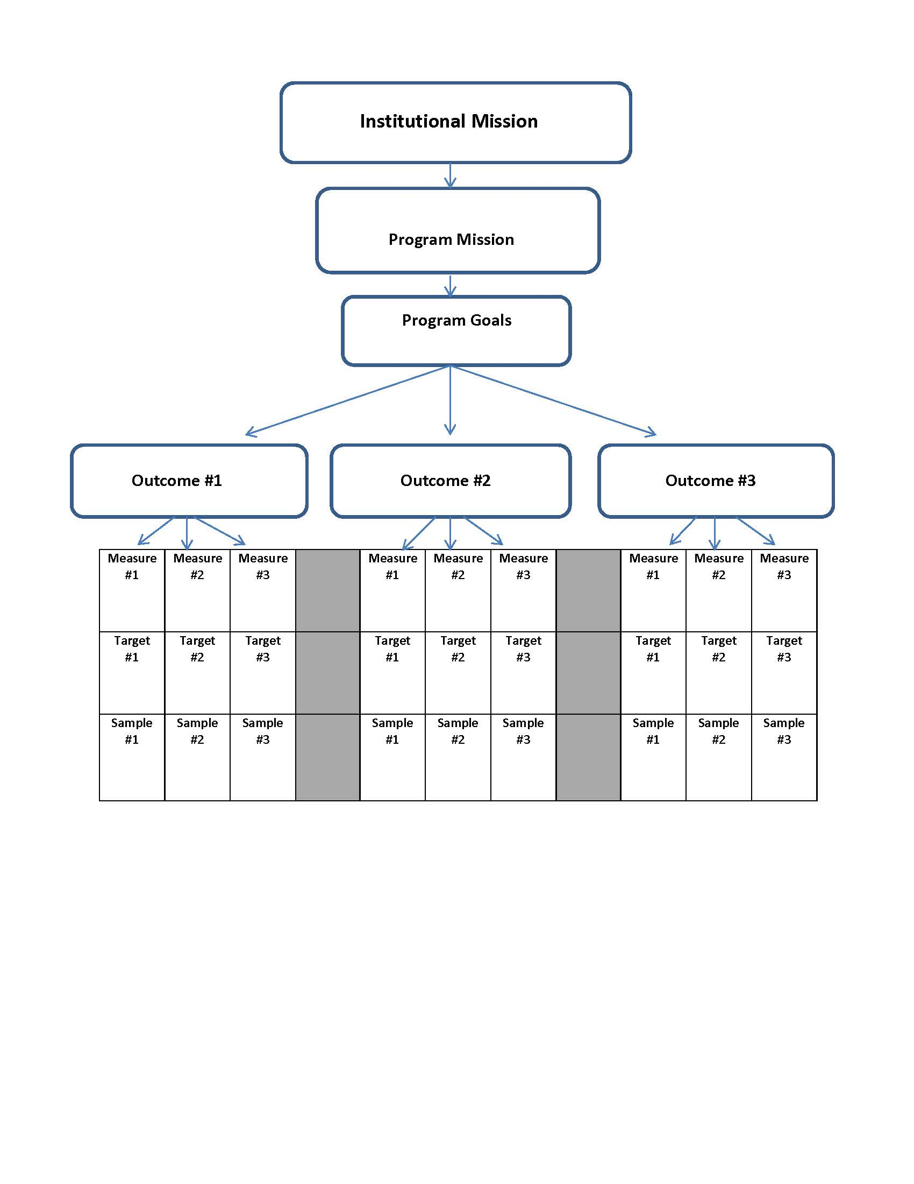

RLNC Form for Assessment Planning
Interpret Results and Report
Outcome #1
Measure #1
Targets for Measure #1 | 1.  2.  3.
Sampling Frames for Measure #1 | 1.  2.  3.
Measure #2
Targets for Measure #2 | 1.  2.  3.
Sampling Frame for Measure #2 | 1.  2.  3.
Measure #3
Target for Measure #3 | 1.  2.  3.
Sampling Frame for Measure #3 | 1.  2.  3.
How many students were included in the data collection for each Measure? How were they selected?

Please provide a brief analysis of your data for each measure. Attach assignments and scoring rubrics.

Do your data indicate that each Target was met? Partially met? Not met? Not reported this cycle?
(If not, please indicate the reason).

Please provide a brief summary of the factors you believe contributed to these results:

Outcome #2
Measure #1
Targets for Measure #1 | 1.  2.  3.
Sampling Frames for Measure #1 | 1.  2.  3.
Measure #2
Targets for Measure #2 | 1.  2.  3.
Sampling Frame for Measure #2 | 1.  2.  3.
Measure #3
Target for Measure #3 | 1.  2.  3.
Sampling Frame for Measure #3 | 1.  2.  3.
How many students were included in the data collection for each Measure? How were they selected?

Please provide a brief analysis of your data for each measure. Attach assignments and scoring rubrics.

Do your data indicate that each Target was met? Partially met? Not met? Not reported this cycle?
(If not, please indicate the reason).

Please provide a brief summary of the factors you believe contributed to these results:

Outcome #3
Measure #1
Targets for Measure #1 | 1.  2.  3.
Sampling Frames for Measure #1 | 1.  2.  3.
Measure #2
Targets for Measure #2 | 1.  2.  3.
Sampling Frame for Measure #2 | 1.  2.  3.
Measure #3
Target for Measure #3 | 1.  2.  3.
Sampling Frame for Measure #3 | 1.  2.  3.
How many students were included in the data collection for each Measure? How were they selected?

Please provide a brief analysis of your data for each measure. Attach assignments and scoring rubrics.

Do your data indicate that each Target was met? Partially met? Not met? Not reported this cycle?
(If not, please indicate the reason).

Please provide a brief summary of the factors you believe contributed to these results:

Action Plan
Action Plan Title
Action Steps
Estimated Implementation Date
Priority
Person(s) Responsible
Expected Outcome
Resources Requested
Estimated Cost(s)
Status Update

