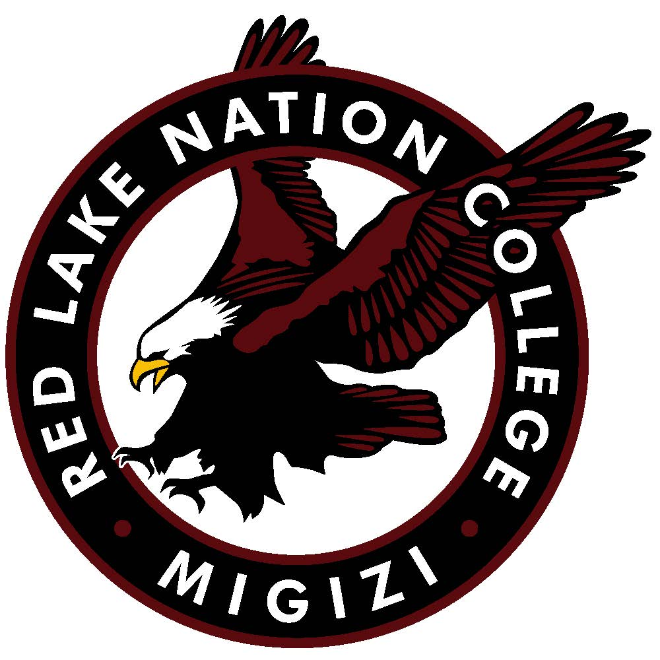
Red Lake Nation College
Multimedia Participant Consent Form

I, the undersigned, grant permission and consent to Red Lake Nation College and its successors and assignees the right to record, use, reproduce, and distribute my voice, image, name, writings, photos, videos, and are work in multimedia productions for educational, publication, or marketing purposes at Red Lake Nation College.
I understand that Red Lake Nation College shall have total and exclusive control of this multimedia material and I waive any right to inspect or approve any proposed use in any media format.
I agree that my participation in this project is on a volunteer basis without any compensation and hereby waive any payment or rights to royalties.
I hereby release Red Lake Nation College and its successors and assignees form any liability in connection with the use of this multimedia material.
I state that I am at least 18 years of age and am competent to contract in my name. A parent or guardian must sign for all participants under the age of 18.
I have read and understand this Multimedia Participant Consent Form and acknowledge that it is firm and final and that Red Lake Nation College may proceed in reliance thereon.
______________________________________________________________________________
Signature Date
______________________________________________________________________________
Printed Name E-mail Address
______________________________________________________________________________
Address City State Zip
RNLC: Student Faculty Staff Alumni Other: __________________
For Participants Under 18 Years Old
______________________________________________________________________________
Parent/Guardian Signature Date
______________________________________________________________________________
Printed Name
Please return this form to Red Lake Nation College, PO Box 576, Red Lake, MN 55671

